***Creating sequence for the table:***

*create sequence empid_seq*

*start with 1000*

*increment by 1*

*minvalue 1000*

*maxvalue 2000*

*nocycle*

*cache 20;* 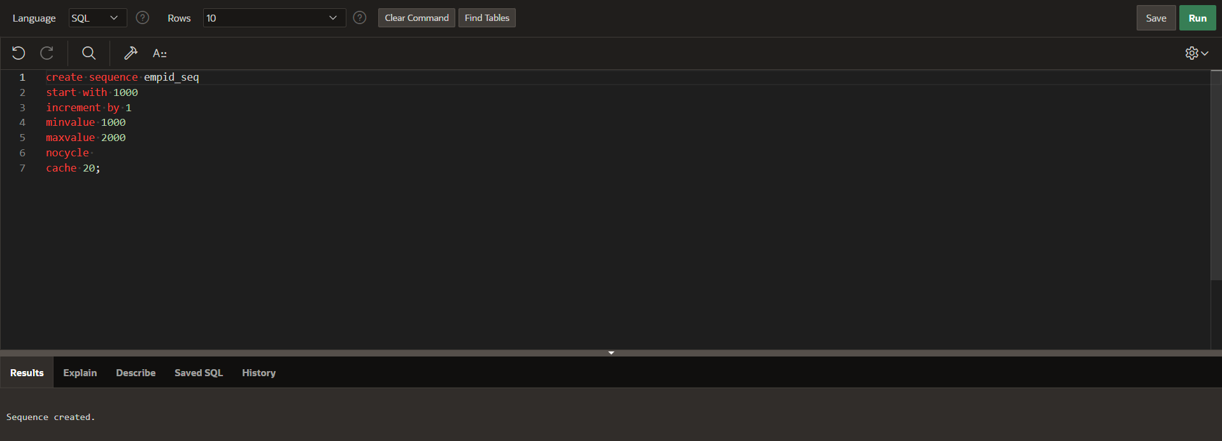

**creating employee table:**

create table employee(

emp_id int primary key,

emp_name varchar(20),

emp_phone int,

dept_id int

);

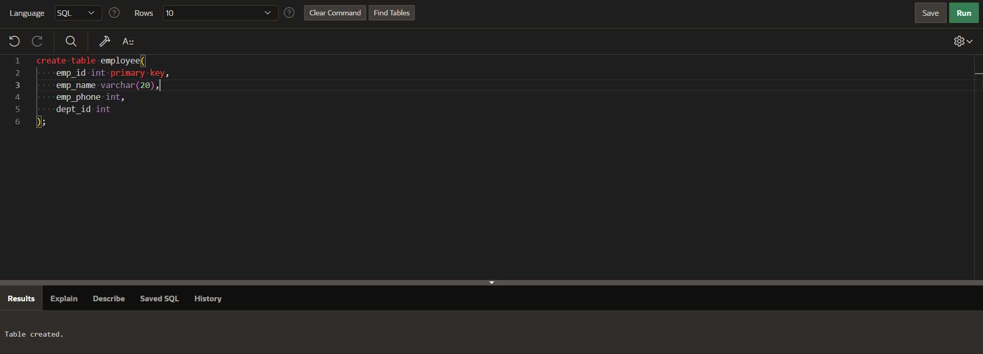

**Inserting vaule in employee table using sequence:**

insert into employee

values(empid_seq.nextval,'rupesh',123456,10);

insert into employee

values(empid_seq.nextval,'uday',987654,11);

insert into employee

values(empid_seq.nextval,'harshit',74912749,10); 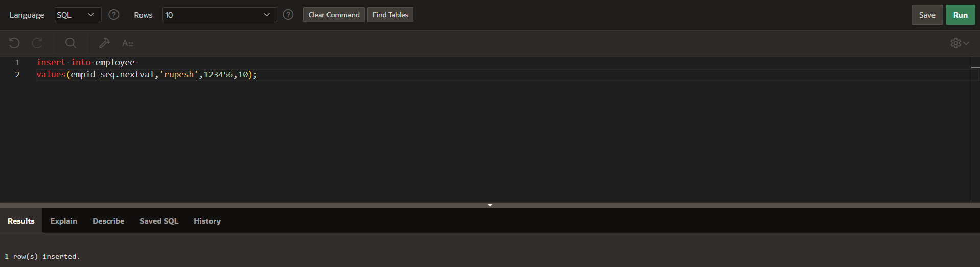

**creating department table:**

create table dept(

dept_id int primary key,

dept_name varchar(20)

);

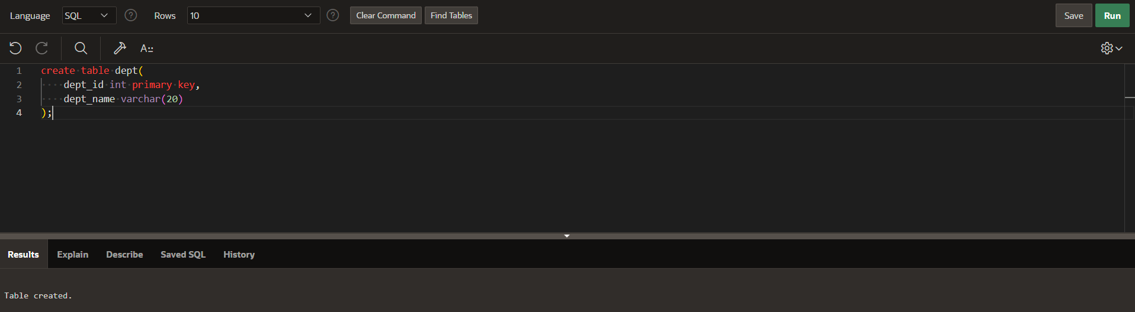

**Inserting data into department table:**

insert into dept

values(10,'human resources');

insert into dept

values(11,'IT');

insert into dept

values(12,'Legal'); 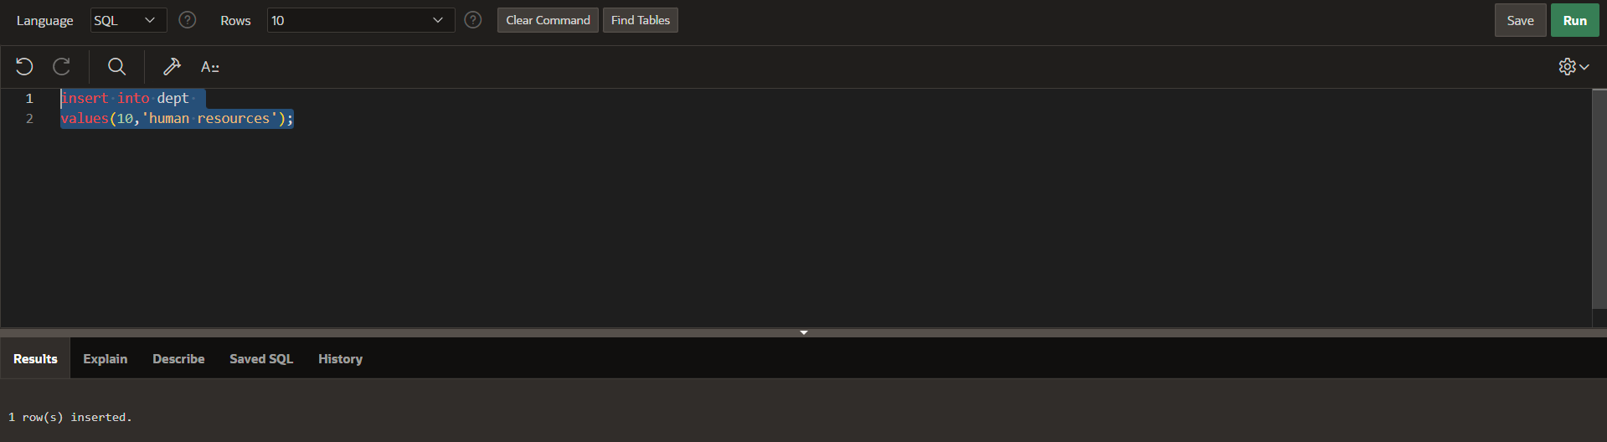

**creating view for employee table:**

create view employee_view as

select emp_id,emp_name,dept_id

from employee;

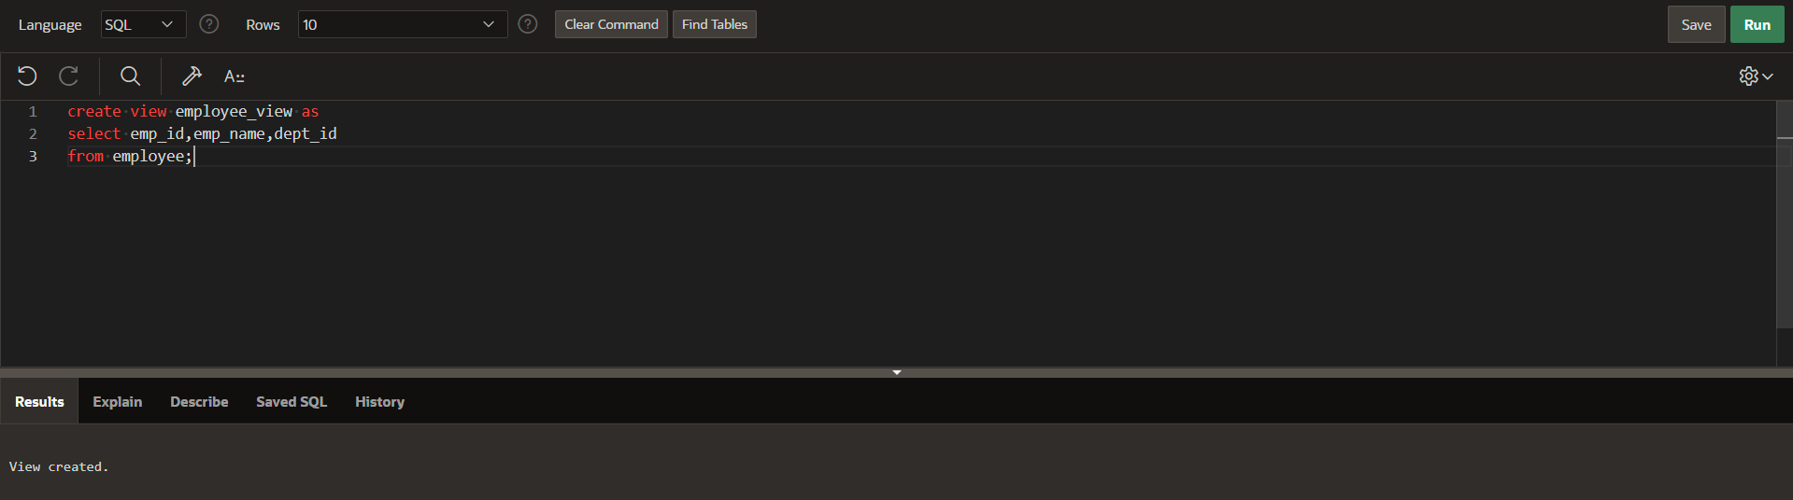

**Displaying the employee table view:**

select *from employee_view; 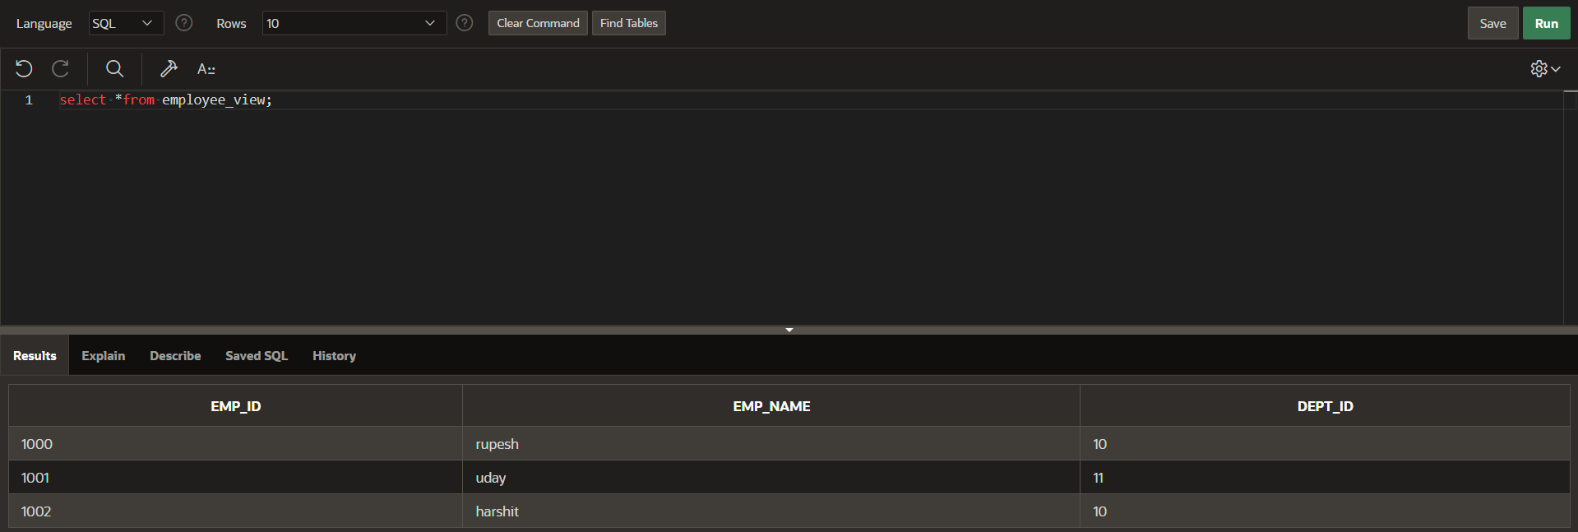

**creating view for department table:**

create view dept_view as

select dept_id,dept_name

from dept; 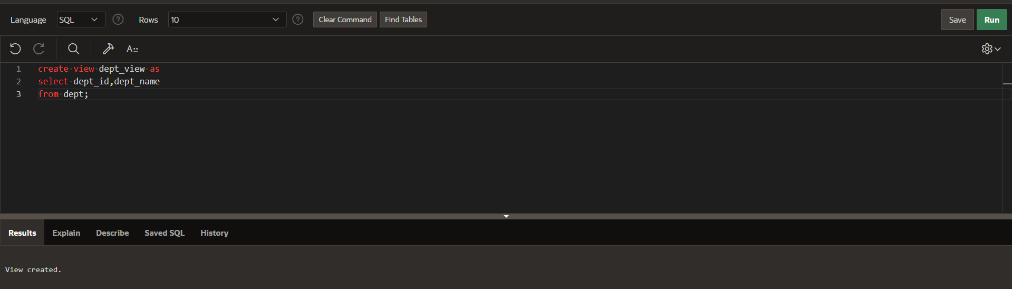

**displaying the department table view:**

select *from dept_view; 